CO1/EXP2/Software
Logical, Bit-Manipulation and Shift Operations Using 8-bit and 16-bit Data Manipulation

a) Verification of Bit Masking Operations Using 8-Bit Processor Assembly Language Programming
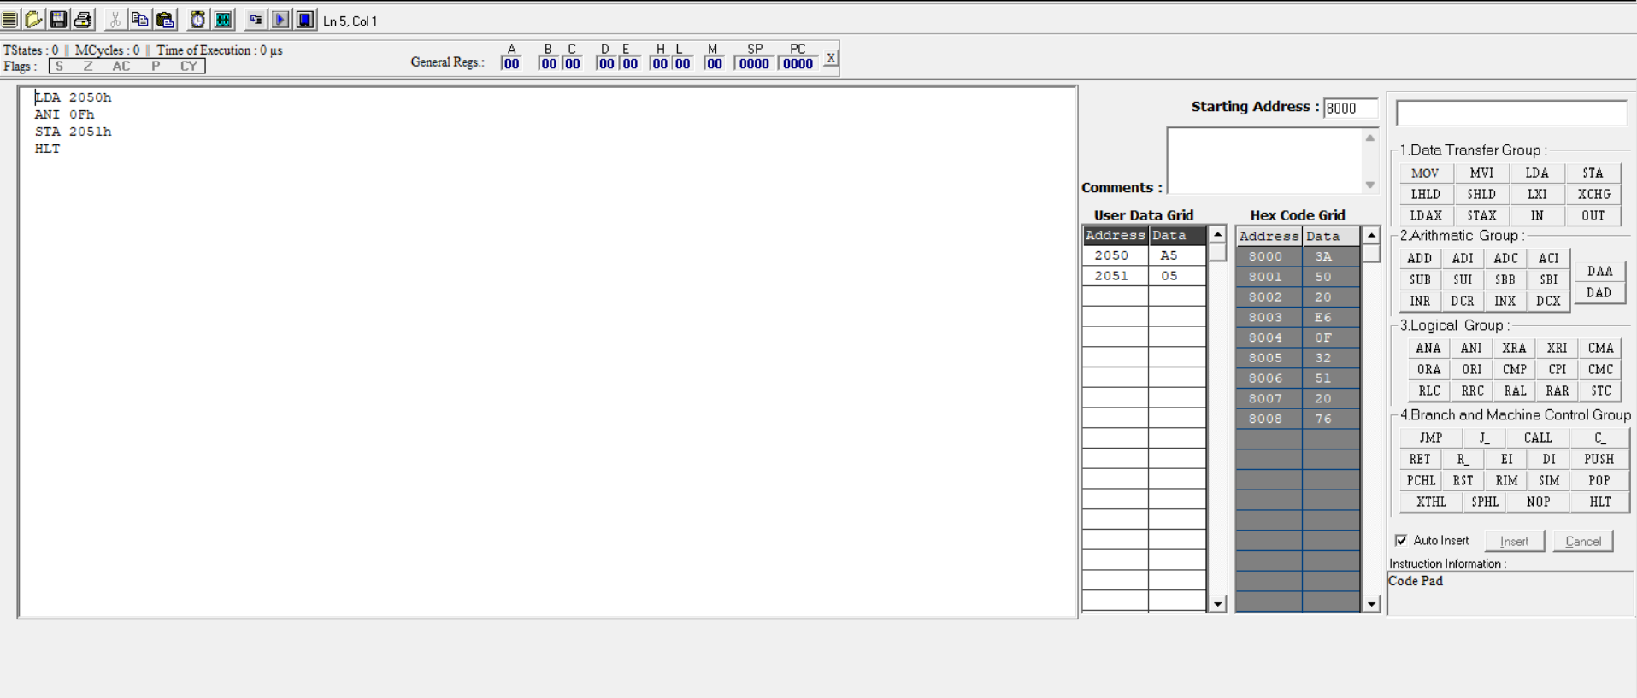
b) Testing of Bit Setting and Clearing Operations Using 8-Bit Assembly Language Programming


